**Solutions to the Questions at end of Assignment:**

**1. What is the emissions per capita of Canada?**

**Ans :** 17.72

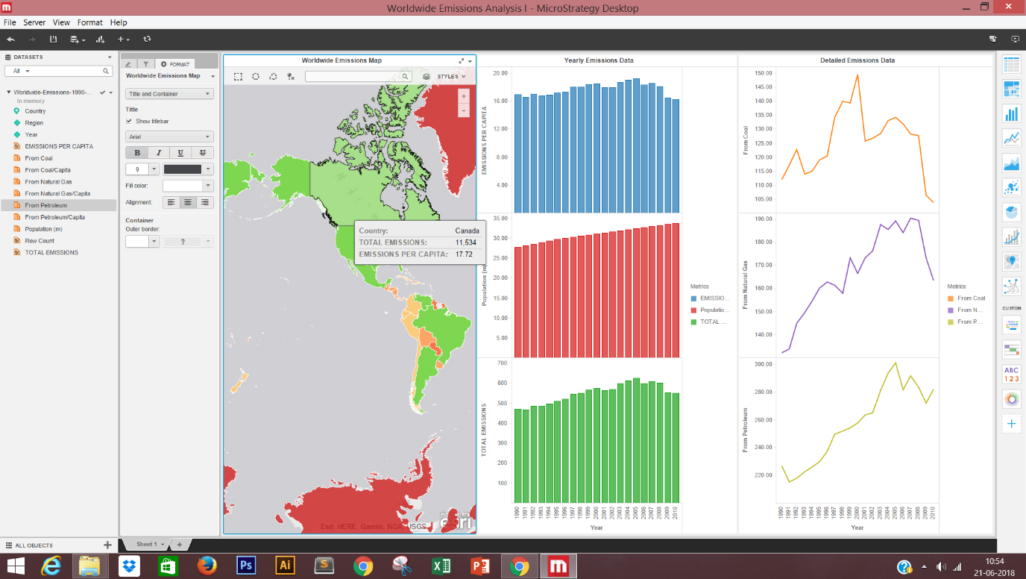

**2. What is the overall trend in worldwide emissions?**

**Ans :** Emissions are increasing each year except in 2009 where it decreased once, we can see the bar chart showing more emissions as year increases . Line chart going upward and going down at 2009 once.

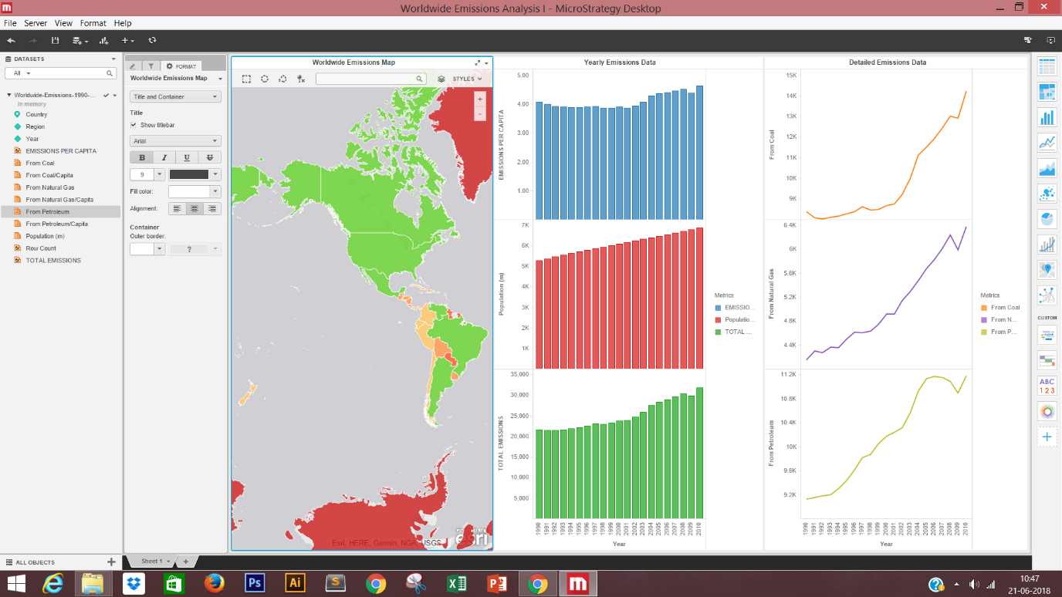

**3. Notice that overall emissions declined in 2009, the only year in the total number of years surveyed that indicates emissions decreases in all three emissions sources. Why is that? What broader socio-political context might explain this single yearly decrease?**

**Ans :** Emissions decreased in 2009, due to global recession. We can observe this fact by seeing the data for USA which shows drastic decrease in emissions from Petroleum and Coal. This shows that rich countries like USA have started opting for more alternative fuels to reduce emissions on a whole. Showing data for USA below :

